Coordinate Geometry Proof Practice
(you may have to use a separate sheets of paper for this – you'll need lots of room for some)
Tips for doing Coordinate Geometry Proofs:
- Organize your work and label everything. Do not just perform calculations all over the place and leave your teacher to figuring out what is what (because we won’t!).
- label your algebra statements clearly
  - so, for example, if you’re going to prove the figure on the next page is a parallelogram by definition, one thing you’ll need to do is find the slope of . When you show that, write something like .
- you must refer to your calculations and provide a summary/proof statement when done. So, for example, if you have just finished finding 4 slopes and are now ready to say that it is a parallelogram, then you would finish with something like this:
  - because both have slopes = -1/4
  - because both have slopes = 4/1
  - since both pairs of opp. sides are , it’s a by def.
- do NOT turn nice fractions like ¾ into decimals – reduce all fractions
- you must show algebraic work for things in your proofs – you can not just simply, for example, look at the graph paper and write down the pt. where it looks like 2 lines intersect – you must use some algebraic way to find the point

Here is some warm-up/review for the proofs on the following pages(feel free to skip this is your linear alg. is already solid):
- What is the equation of the line that goes through (1, 3) and (5, 12)? Leave your answer in
slope-intercept form.

- What is the midpoint of (1, 3) and (5, 12)?

- What is the distance between (1, 3) and (5, 12)?

- What is the equation of the line that is to the line in #1 and also goes through (0, -1)?

- What is the equation of the line that is ⊥ to the line in #1 and also goes through (0, -1)?

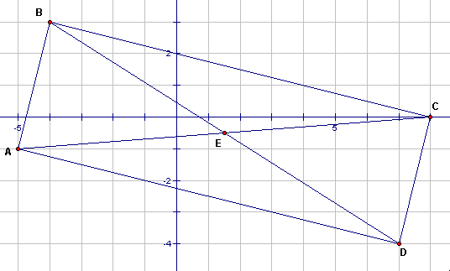

- Given the figure above, prove that it is specifically a rectangle and not a square. There are many ways to do this. Let’s practice a few. Prove it’s a rectangle by:
- showing it’s a parallelogram with one right angle and 2 sides are not ≅.

- showing that the diagonals are congruent and bisect each other and 2 sides are not ≅

- showing that the quadrilateral has 4 right angles and the diagonals are not ⊥

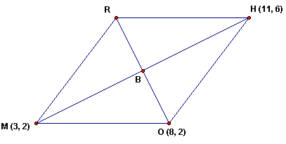
- If the above quadrilateral is a rhombus, what is the coordinate of R (show how you get it and say why your method works)?

  - now prove that RHOM is a rhombus

  - find the coordinates of B (do so by finding equations for and and solving the system of 2 equations)

  - give another way to do problem b) and explain

d) prove that ∆ RBH ≅ ∆OBM (again, using coordinate geometry)
3. Being as specific as possible, what type of figure
is this? prove it.
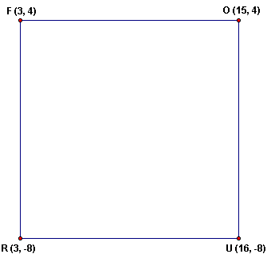

Find the midpoints of and and label them A and B, respectively.

Find AB.

Show that AB = ½ of (RU + FO) and parallel to both bases.

